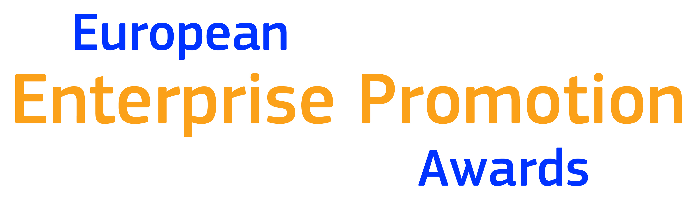
2021

ENTRY FORM

Entry forms should be completed and submitted electronically to the national EEPA co-ordinator (address at end of form) in both word and pdf versions. Hard copy entry forms will not be accepted at second stage of entry (European level)

Section I: General information
1. Applicant’s details
Please ensure that all information given below is correct as it may be used on any published material
Name of Project/Initiative
(in English, unless you require the Project Name to appear in your native language)
Name of participating organisation
(in English, unless you require your Organisation Name to appear in your native language)
Description of Project/Initiative in one sentence
Which Award Category would you like to be considered for?  (Note: you can apply for one category only; the Jury reserves the right to change the category if deemed necessary) | 1.Promoting the Entrepreneurial Spirit
 | 2.Investing in Entrepreneurial Skills
 | 3. Improving the Business Environment and supporting the digital transition
 | 4.Supporting the Internationalisation of Business
 | 5.Supporting the sustainable transition
 | 6. Responsible and Inclusive Entrepreneurship
Project Duration  (projects must have been in existence for at least 15 months) | Start Date
 | End Date
Third Party Endorsement/s Providers
(for details see page 2)
Contact person (name and job title)
Contact’s e-mail
Contact telephone number
Website address
Town and Country
National Coordinator Name

Section II: Information about the Initiative
This section deals with what the initiative is about, how it is being implemented and its benefits.

1. Description of the initiative
Provide a detailed description of the initiative, addressing the following key points: objectives; target group; situation analysis; challenges; creative solution/business strategy; implementation, stakeholder involvement, future implementation plan. A case-study of the project with a local or regional example must be included if it is a national initiative.
maximum 500 words (approximately 1 page)

2. Results of the initiative
Provide detailed facts and figures of the initiative. These results must demonstrate that the initiative has existed for 15 months at least. They should include any measurable outcomes, statistical and comparative data.
maximum 500 words (approximately 1 page)

3. Innovation
Explain what is new and innovative about your initiative and how this isn’t being done already.
maximum 250 words (approximately 1/2 page)

4. Initiative details
List all of the public and private sector organisations involved in the initiative  In case of public and private partnership arrangement, is it:  - A financial agreement  - A formal agreement  - An explicit support  Describe the details of the partnership agreement | Yes □ No □  Yes □ No □  Yes □ No □
What was the overall budget invested in this initiative? Separate and list any reciprocal or human resource investment.
Did you receive European Union funding? | Yes □ No □  If yes, how much? ________________  Which type? ___________________

5. Third-party endorsement
Please attach as a pdf document, an endorsement letter signed by a high level local figure who has independent knowledge of the initiative. This could be from a politician, entrepreneur, academic or business organisation, but they should not be financially or otherwise involved in the organisation of the initiative.

Section III: Publicity & Media

By entering the European Enterprise Promotion Awards you agree to have your initiative and organisation publicised. The organisers of the Awards reserve the right to edit any media copy supplied by the initiative.

1. Electronic Links
You may include up to five links to visual or audiovisual material that promotes your initiative. This material will help the Jury to understand your entry and may be used for promotional purposes. Be aware that these links will not be translated into English.

Videos, which may be used in the Awards Ceremony and presentations should be submitted in HD (720p or 1080p) and the preferred format would be MP4.

Please list the URLs of video links.

2. Promotional Material
Please provide the following: -

- Logo – illustrator vector file/eps of your logo.
- Image - a landscape high resolution image preferably 300 DPI jpeg/pdf of your project/team.

3. Media Copy
Please provide 100 words suitable for media purposes, describing the initiative and its results.

4. Quote
As a successful National Winner, please provide a short quote, as to what it is like to receive an award at national level. (max 50 words)

5. Public Relations/Media contact at your organisation, if different from main contact.

Name:
Title/function:
Telephone:
Fax:
e-mail:
Section IV: Entrant agreement

As legal representative for the initiative, I agree that it may be submitted for entry in the 2021 European Enterprise Promotion Awards. I declare the material submitted in the entry is a true and correct reflection of the initiative.

In the event that this initiative is selected as a nominee for the 2021 European Enterprise Promotion Awards, I agree to have our initiative and organisation publicised on the Awards’ website and information distributed to the media.

Name of legal representative:
Title/function:
Date:
Signature:

By completing this application form, entrants give their consent to the processing of personal data to the extent necessary for the achievement of the purposes mentioned above. The EC guarantees that personal data relating to delegates are processed according to the rules set by the Regulation (EC) No 45/2001. Data may be archived by the EC.

Please send the completed and signed entry form to:

Jelena Scekic
Republic of Serbia
Ministry of Economy
Department for SME Development
Kneza Milosa 20, 11 000 Beograd, Republika Srbija
T: +381 11 333 4213
E: jelena.scekic@privreda.gov.rs
W: www.privreda.gov.rs

Milica Stankovic
Republic of Serbia
Ministry of Economy
Department for SME Development
Kneza Milosa 20, 11 000 Beograd, Republika Srbija
T: +381 11 333 4144
E: milica.stankovic@privreda.gov.rs
W: www.privreda.gov.rs

Entry rules
- By entering the national selection, you agree that in the event your entry is nominated, you will accept to represent your country in the European Enterprise Promotion Awards.

The competition is open to public authorities in the EU member states, as well as associate countries in the COSME programme and the United Kingdom.

- Eligible entities include national organisations, towns, cities, regions and communities as well as public-private partnerships between public authorities and entrepreneurs, educational programmes, and business organisations.

- Cross-border initiatives will be accepted as long as they are nominated jointly by all countries involved.

- Closing date for entries of the national selection will be announced by the EEPA national coordinators.

- Maximum length of application as detailed in the entry form must be observed

- No hard copy material will be accepted at European level – and only up to 5 links will be accepted within the electronic entry form

- Entries at the European level can be submitted in any one of the official EU languages.

- Entries will be evaluated against the following criteria:

  - Originality & feasibility: why is the project a success? What are its innovative aspects?
  - Impact on the local economy: provision of figures to substantiate success claims
  - Improvement of local stakeholder relations: has more than one interested party benefited from the implementation of this initiative? Why were they involved and what was their level of participation?
  - Transferability: could the approach be repeated in the region and elsewhere around Europe?

- There is no entry fee.

