Please complete the following single page synopsis sheet. It must not exceed a single sheet of A4

List the Urls of videos included in entry

Name of initiative

Country

Responsible organisation

Contact Person | Name:  Address:  Postcode:  City:  Country:  Email:  Website:
Category

Description of the Initiative

Objectives

Duration of project | Start date:  End date:
Target group

Endorsed by

Key results & achievements

Problems overcome/lessons learned

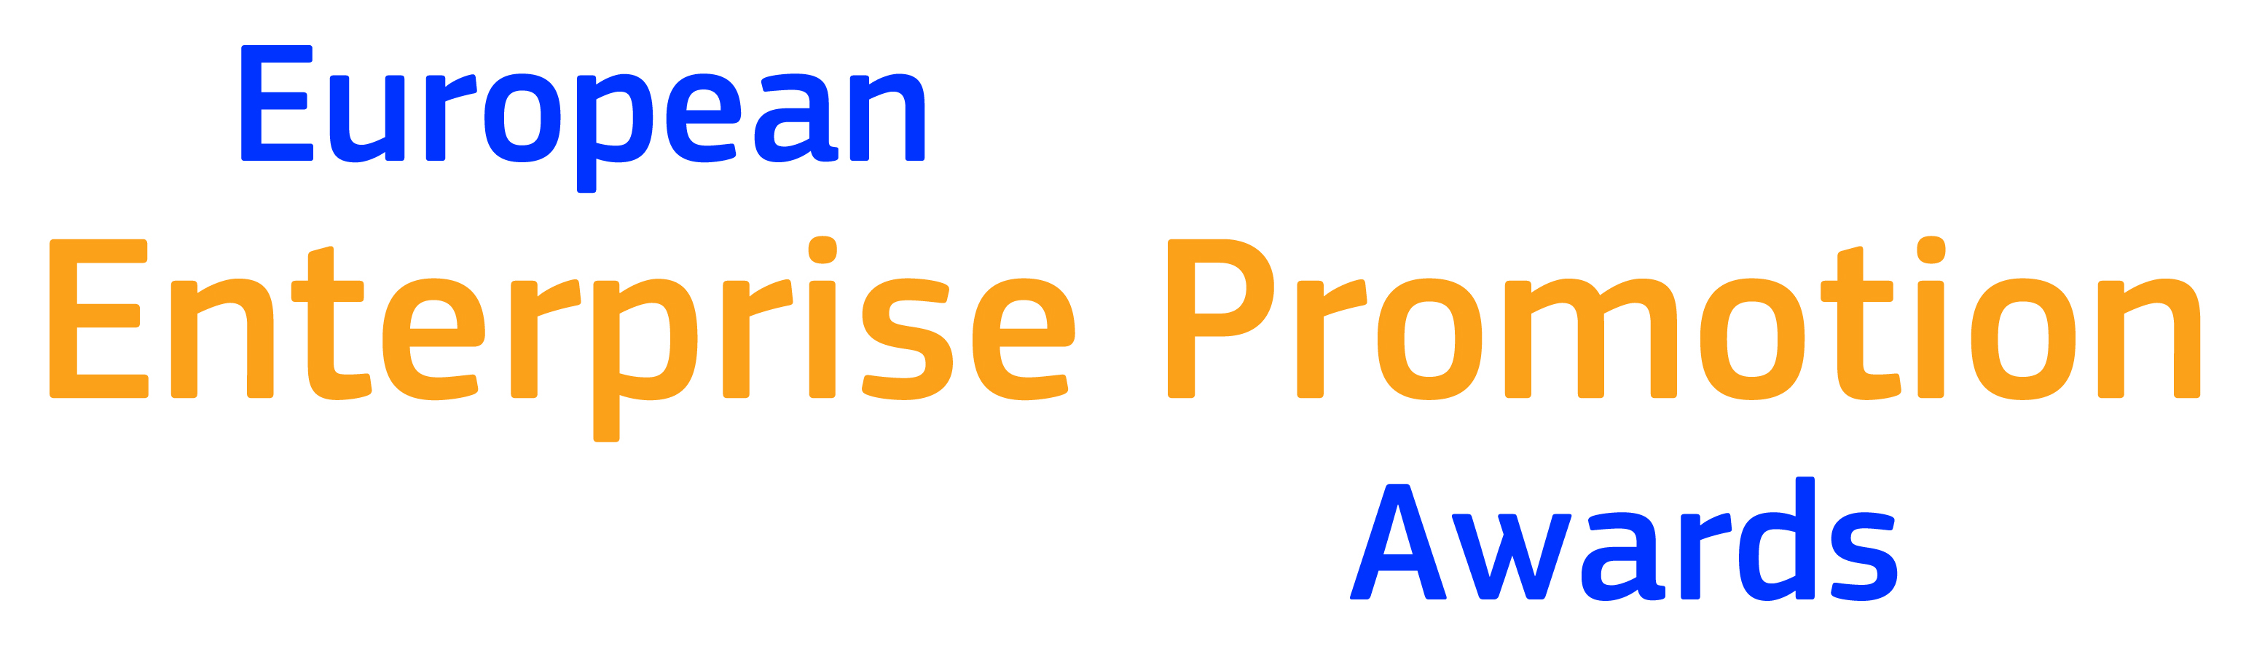
2019

ENTRY FORM

Entry forms should be completed and submitted electronically to the national EEPA co-ordinator (address at end of form) in both word and pdf versions. Hard copy entry forms will not be accepted at second stage of entry (European level)

Section I: General information

1. Applicant’s details

Name of participating organisation
(this exact wording shall be used on all published material)
Postal address
Country
Email address of organisation
Website address
Telephone
Fax
Contact person (name and title)

Contact’s telephone number
Contact’s e-mail

2. Please tick the award category you would like to be considered for.
(Note: you can apply for one category only; the Jury reserves the right to change the category if deemed necessary)
- Promoting the Entrepreneurial Spirit
- Investing in Entrepreneurial Skills
- Improving the Business Environment
- Supporting the Internationalisation of Business
- Supporting the Development of Green Markets and Resource Efficiency
- Responsible and Inclusive Entrepreneurship

Please give a brief description of your organisation and what it does.
(maximum 100 words)

Section II: Information about the Initiative
This section deals with what the initiative is about, how it is being implemented and its benefits.

1. Initiative details
Initiative name:

Initiative name in English language:
(this exact wording shall be used on all published material
List all of the public and private sector organisations involved in the initiative  In case of public and private partnership arrangement, is it:  - A financial agreement  - A formal agreement  - An explicit support  Describe the details of the partnership agreement | Yes □ No □  Yes □ No □  Yes □ No □
Duration of initiative
(minimum 2 years)
- What date did the initiative start?
- What date did the initiative finish?
What was the overall budget invested in this initiative?
Separate and list any reciprocal or human resource investment
Did you receive European Union funding? | Yes □ No □  If yes, how much? ________________  Which type? ____________________

2. Description of the initiative
Provide a detailed description of the initiative, addressing the following key points: situation analysis; challenges; creative solution/business strategy; implementation, stakeholder involvement, future implementation plan. A case-study of the project with a local or regional example must be included if it is a national initiative.
maximum 1000 words (approximately 2 pages)

3. Results of the initiative
Provide detailed facts and figures of the initiative. These results must demonstrate that the initiative has existed for two years at least. They should include any measureable outcomes, statistical and comparative data.
maximum 1000 words (approximately 2 pages)

4. Third-party endorsement
Please attach as a pdf document, an endorsement letter signed by a high level local figure who has independent knowledge of the initiative. This could be from a politician, entrepreneur, academic or business organisation, but they should not be financially or otherwise involved in the organisation of the initiative.

5. Electronic Links
You may include up to five links to visual or audiovisual material that promotes your initiative. This material will help the Jury to understand your entry and may be used for promotional purposes. Be aware that these links will not be translated into English.

Videos, which may be used in the Awards Ceremony and presentations should be submitted in HD (720p or 1080p) and the preferred format would be MP4. The duration of the video should be between 60 seconds and 3 minutes.

Section III: Publicity
By entering the European Enterprise Promotion Awards you agree to have your initiative and organisation publicised. The organisers of the Awards reserve the right to edit any media copy supplied by the initiative.

1. Media copy
1.1 Please provide a single sentence description of the initiative of not more than 75 words. This may be used for media purposes when describing the initiative.

1.2 Please provide 250 words suitable for media purposes, describing the initiative and its results.

2. Public Relations/Media contact at your organisation
Name:
Title/function:
Telephone:
Fax:
e-mail:

Section IV: Entrant agreement

As legal representative for the initiative, I agree that it may be submitted for entry in the 2019 European Enterprise Promotion Awards. I declare the material submitted in the entry is a true and correct reflection of the initiative.

In the event that this initiative is selected as a nominee for the 2019 European Enterprise Promotion Awards, I agree to have our initiative and organisation publicised on the Awards’ website and information distributed to the media.

Name of legal representative:
Title/function:
Date:
Signature :

Please send the completed and signed entry form to:

Milica Stankovic
Republic of Serbia
Ministry of Economy
Department for SME Development
Kneza Milosa 20, 11 000 Beograd, Republika Srbija

T: +381 11 333 4144
E: milica.stankovic@privreda.gov.rs
W: www.privreda.gov.rs

Jelena Scekic
Republic of Serbia
Ministry of Economy
Department for SME Development
Kneza Milosa 20, 11 000 Beograd, Republika Srbija
T: +381 11 333 4194
E: jelena.scekic@privreda.gov.rs
W: www.privreda.gov.rs

Entry rules
- By entering the national selection, you agree that in the event your entry is nominated, you will accept to represent your country in the European Enterprise Promotion Awards.

- The competition is open to public authorities in the EU associates countries in the COSME programme Iceland, Serbia and Turkey.

- Eligible entities include national organisations, towns, cities, regions and communities as well as public-private partnerships between public authorities and entrepreneurs, educational programmes, and business organisations.

- Cross-border initiatives will be accepted as long as they are nominated jointly by all countries involved.

- Closing date for entries o the national selection will be announced by the EEPA national coordinators.

- Maximum length of application as detailed in the entry form must be observed

- No hard copy material will be accepted at European level – and only up to 5 links will be accepted within the electronic entry form

- Entries at the European level can be submitted in any one of the official EU languages.

- Entries will be evaluated against the following criteria:

  - Originality & feasibility: why is the project a success? What are its innovative aspects?
  - Impact on the local economy: provision of figures to substantiate success claims
  - Improvement of local stakeholder relations: has more than one interested party benefited from the implementation of this initiative? Why were they involved and what was their level of participation?
  - Transferability: could the approach be repeated in the region and elsewhere around Europe?

- There is no entry fee.

